**Assignment # 3**

**K20-1052**

**BSE-6B**

**UBUNTU 2022 intalled on VMware**

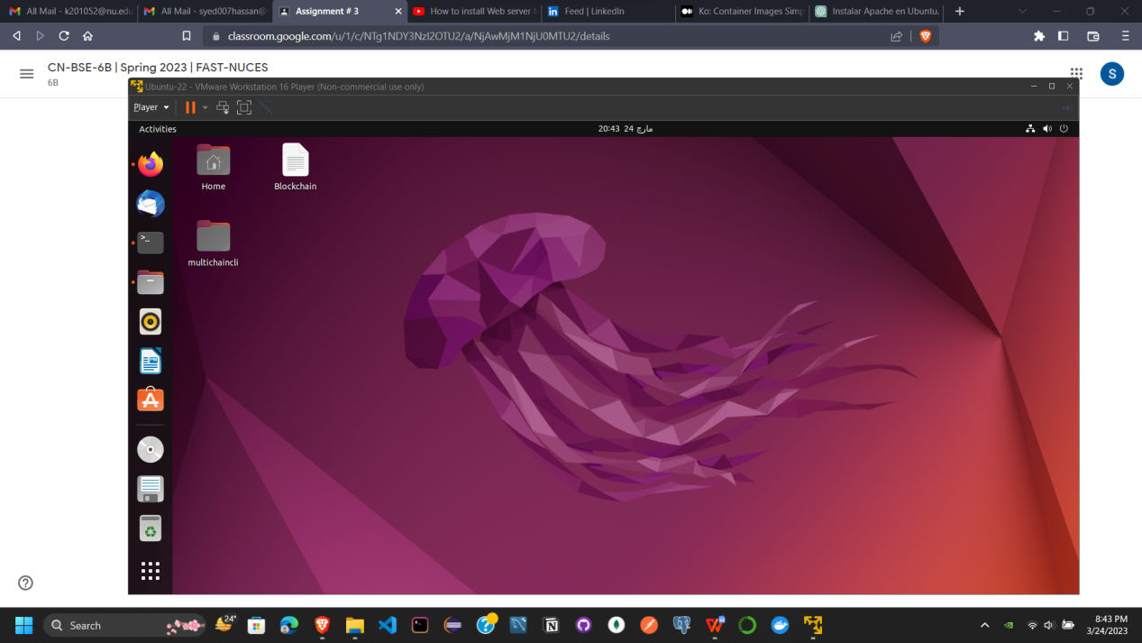

**To install Apache Web server**

* **sudo apt-get update**
* **sudo apt-get install apache2**

**Now Start the server and check its status**

* **systemctl start apache2**
* **sudo systemctl status apache2**

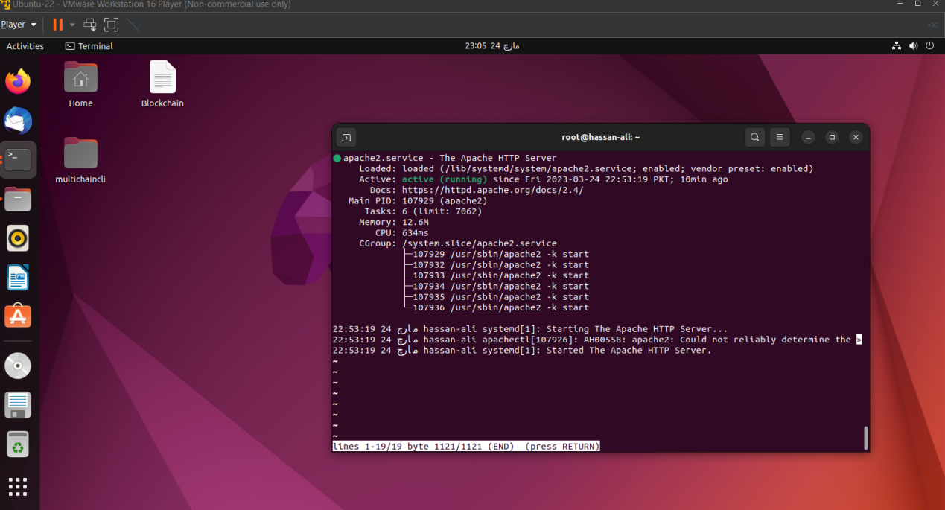

**Server is running on localhost**

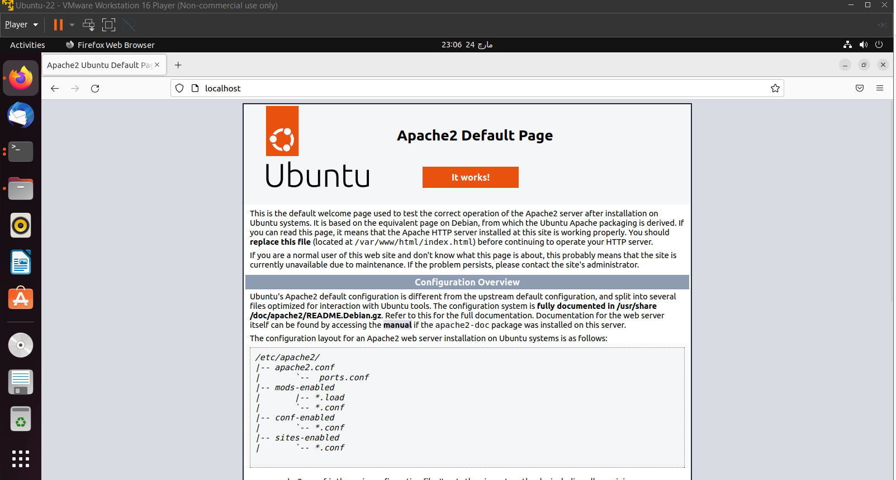

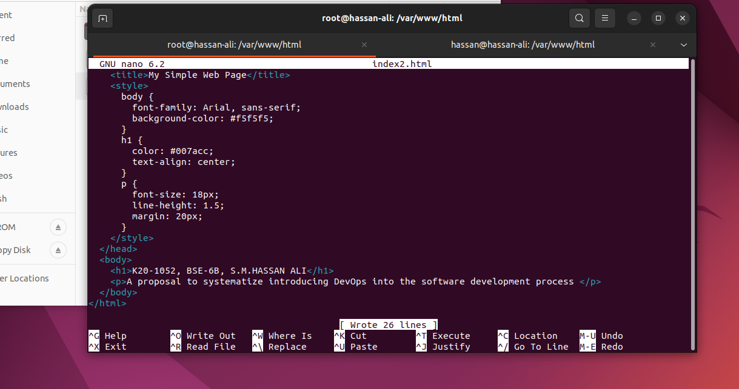

**Opened an index2.html file on Webserver**

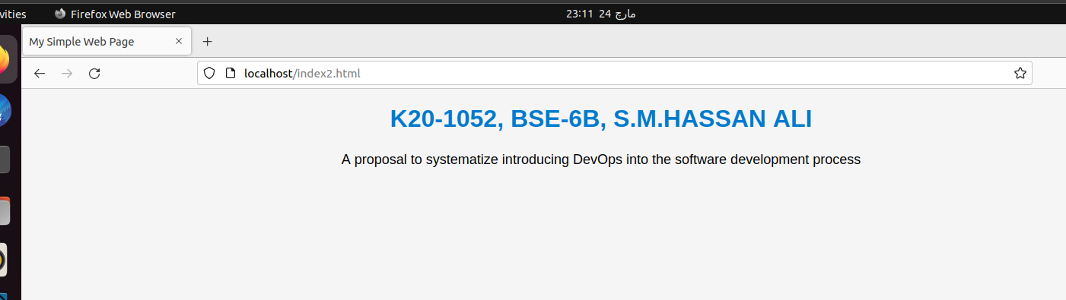

**Testing the connectivity of web server using telnet**

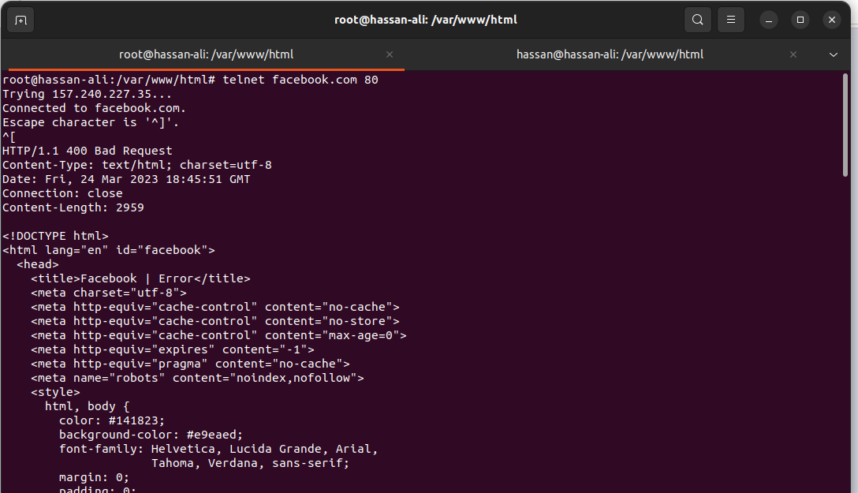

**Now for localhost that is running Apache webserver at 127.0.0.1**

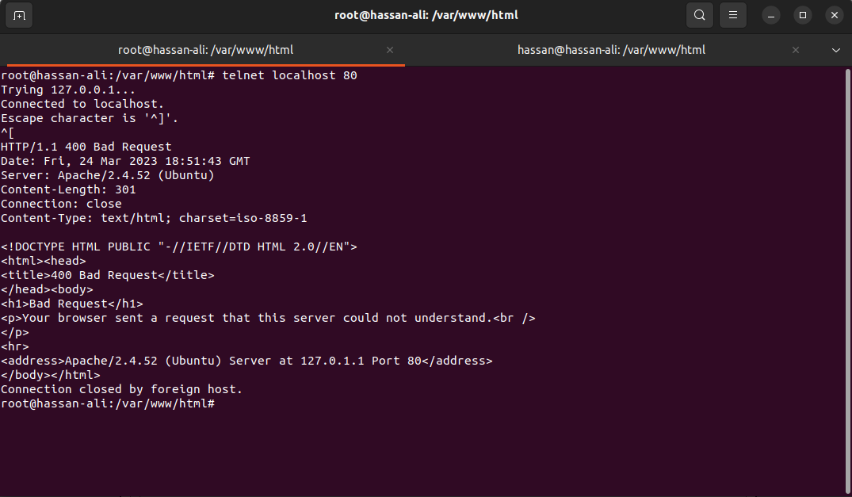

**Now In Windows Server**

